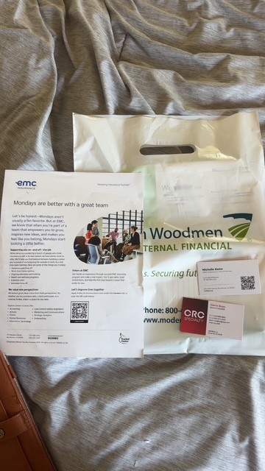

2 weeks ago, I attended the Career fair for a lot of Business majors. I was able to speak to several business professionals and learn about their business and their internship programs. One business that is not seen in the photo above is Principal Financial, which is a huge company in Des Moines. I spoke about a financial analyst internship and have since applied for that opportunity. Overall, this career fair was a great experience and I was very glad I went and spoke to these individuals.

